ENHANCING LIVELIHOOD OPPORTUNITIES THROUGH POULTRY FARMING
Krishi Vigyan Kendra Pulwama
Directorate of Extension (SAMETI) SKUAST Kashmir coordinating Institute

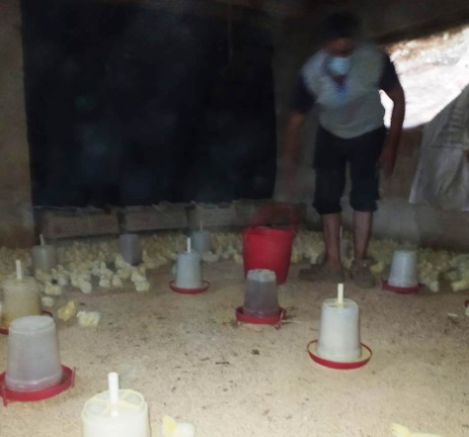
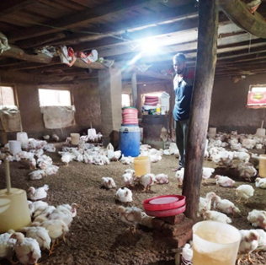
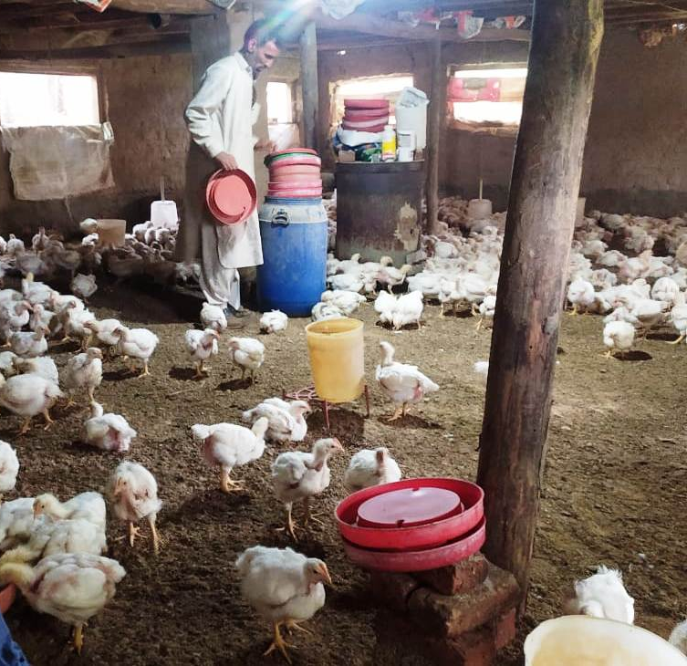

Mr. Abas Kariem Bhat aged 38 has one and half acres of land and is concerned with agronomic (paddy/mustard/oats) and horticulture crops to earn a livelihood. The agronomic crops especially rice being labour and water intensive provides him with little means to satiate his family needs. The limited apple plantation (1 kannal) he has often bears the brunt of calamities and diseases leaving little or no income in his hands.
Taking account of the keen interest of Mr. Abas for enhancement and diversification of farm income and to offset the negative impact of diseases and natural calamities, he was advised to enrol for the STRY on enhancing livelihood opportunities through poultry farming. The programme conducted from 15th to 20th Feb2021 by KVK Pulwama in association with SAMETI (SKUAST Kashmir) and sponsored by MANAGE Hyderabad, enabled Mr. Abas to acquire skills regarding care, brooding, health and housing management of birds and at the same time looking for ways and means to market the produce for better returns. Due attention was paid to arrange on farm visits for participants to poultry farms in and around, so as to enable the participants of the STRY programme receive hands on training andfirsthand experience with regard to poultry farming. Resource personnel from Department of Animal Husbandry, Entrepreneurship development institute (JKEDI) and lead bank were invited to apprise theparticipants of various state and central govt schemes aimed at promotion of poultry farming. The training programme enabled Mr. Abas to diversify means of production and earn a handsome living. This not only helped him to save earnings but also living to the expectations of his family.
Economics: Mr. Abas is able to earn a net income of 20000 INR per hatch of 1000 chicks, that translates to some where around 15000 per month (9 hatches per year).

Modification introduced by successful youth
- The training module enabled Mr. Abas to raise and manage birds in a better way with mortality rates well below the justifiable level of 5%.
- Mr. Abas was well adept at using alternatives to antibiotis such as organic acids, probiotics and prebiotics to promote bird health and welfare and at the same time minimising effort and cost needed to control bacterial infections.
- Explored the online means to market produce at right time for better returns.

Impact on farmers/ youth
- Looking at the succes of Mr. Abas three more trainees have started construction of rearing facility for birds.
- With growing returns from broiler farming and keeping in view demand for brown free-range eggs, Mr. Abad has integrated back yard layer birds (Vanraja and key stone golden) in his one kanal apple orchard to produce more from the limited piece of land.
- The profitable broiler farming by Mr. Abas has kindled a ray of hope among those poultry producers who find it difficult to manage their production units on economically viable lines, which along with Mr. Abas has motivated a group of youth to explore the ways and means of delivering dressed birds to the door steps of the customers, so as to avoid exploitation at the hands of middle men.

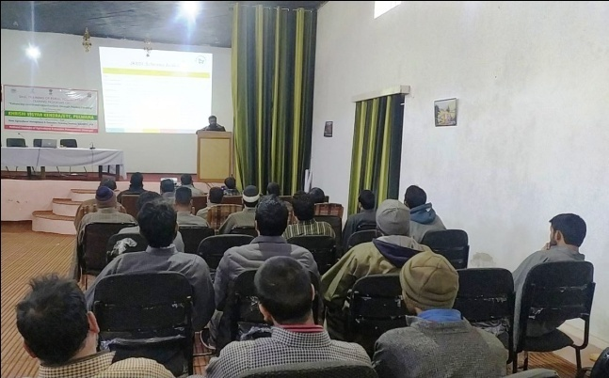
Coverge of the programme
- Introduction to poultry farming
- Scope and opportunities of poultry farming in Kashmir valley.
- Site selection of poultry shed. Different types of poultry housing system.
- Equipment/tools used in poultry shed.
- Housing requirements and management.
- Maintenance of standard environmental conditions in poultry shed.
- Brooding and care of chicks from day old to first two weeks.
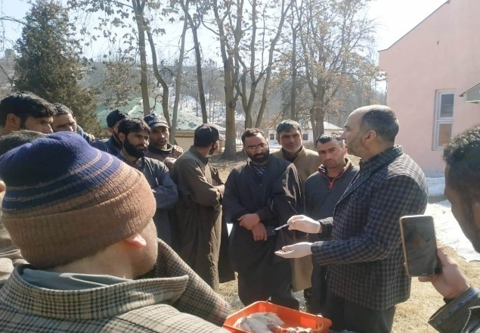
- Routine manage-mental practices in poultry rearing. Nutritional and health management of birds.
- Bio-security measures for containment of the diseases.
- Managing the waste in a poultry shed.
- Poultry disease diagnosis through post-mortem examination.
- Visit to progressive poultry farms for a firsthand experience.
- Sponsored schemes for development of poultry sector and role of Animal Husbandry department and JKEDI in promoting poultry farming.

Details of the experts
S.No | Name | Area of expertise | Email Id
 | Dr. Malik Raies Ul Islam | Scientist Animal Science | maikrayees@gmail.com
 | Dr. Ishtiyaq Ahmad | Scientist Animal Science | Dr.ishtiyaq83@gmail.com
 | Dr. Shahid Ahmad | Scientist Animal Science | Drshahid21uk@gmail.com
 | Dr. Bilal Ahmad | LDO Awantipora | cahopulwama@jkahd.net
 | MrAnsarullahMachloo | JKEDI | Jkedi.pulwama@gmail.com
 | Mr. Imran | Mother Poultry Farms | -

Details of associated STRY Team
Training Coordinator  Dr Malik Raies Ul Islam  Email Id: malikrayees@gmail.com  Phone: 7006224505 | Director  Prof. Musarat Shafi  Head KVK/ETC Pulwam  Email: pcpulwama@gmail.com  Phone:9797144702
Nodal Officer (STRY)
Dr Farah Naz
Email: -
Phone_7298446815

